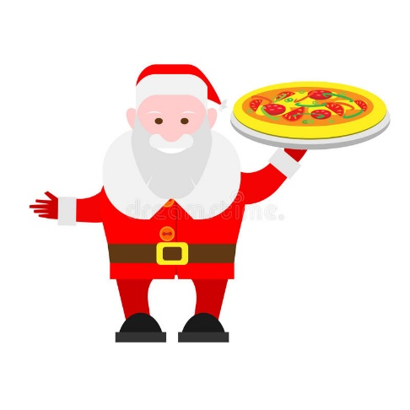

Mail your letters to Santa from the Firehouse!

Have your picture

taken with

Santa!!

Avoid the lines at the mall!!

Christmas Crafts

For Kids!

Saturday, December 15th

Noon – 3:00pm

4911 Prince Georges Ave. Beltsville, MD 20705

www.beltsvillevfd.com

$5.00 per person

**PIZZA WITH SANTA**

**Beltsville Volunteer Fire Department**